Test Case: tc005_SPX_Dev5_Crear_Requisicion_Spot_Con_FAD_Tipo_Cobro_Project
Step 1 - Enter username and password and click to button Enter: Credentials Entered
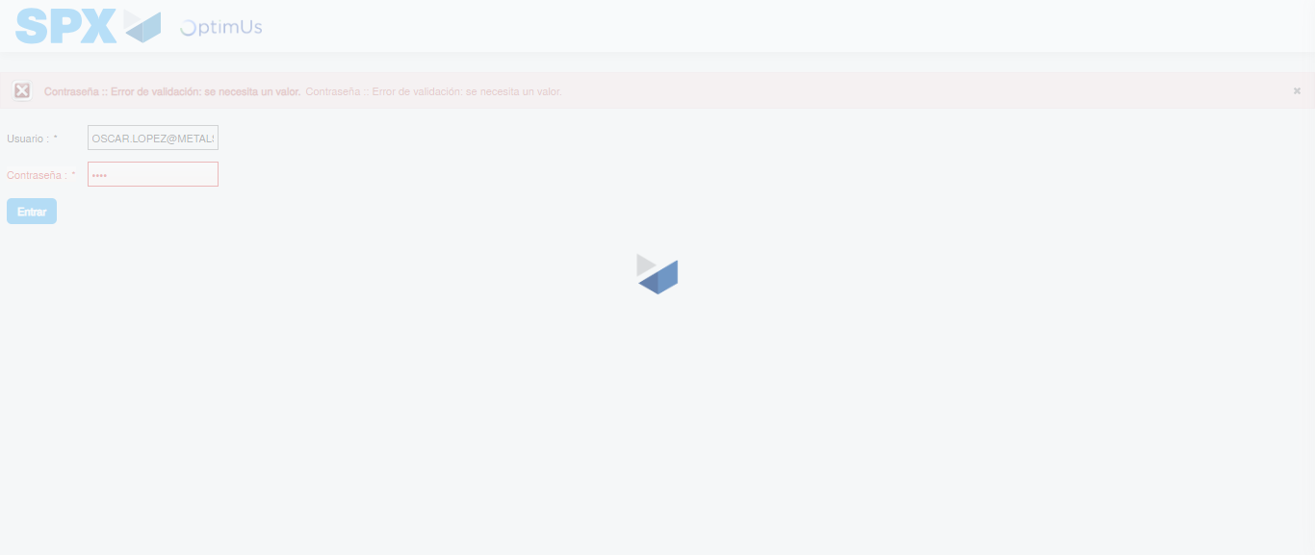Image file-name: QC_Testing-tc005_SPX_Dev5_Crear_Requisicion_Spot_Con_FAD_Tipo_Cobro_Project-1784572939177

Step 2 - Select to UEN and Access to Spot Buy Requisitions : UEN Correctly selected and Correct access
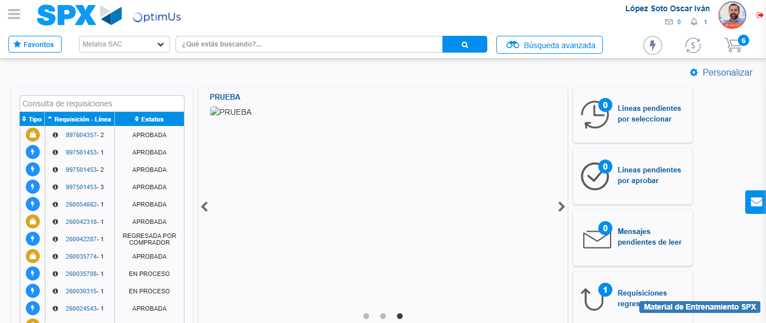Image file-name: QC_Testing-tc005_SPX_Dev5_Crear_Requisicion_Spot_Con_FAD_Tipo_Cobro_Project-1784573006677

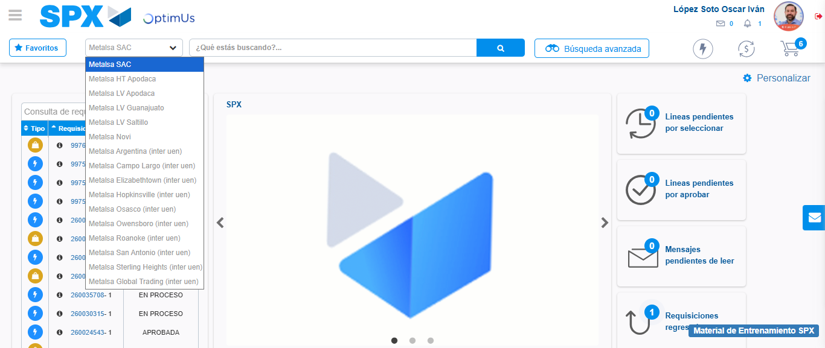Image file-name: QC_Testing-tc005_SPX_Dev5_Crear_Requisicion_Spot_Con_FAD_Tipo_Cobro_Project-1784573009455

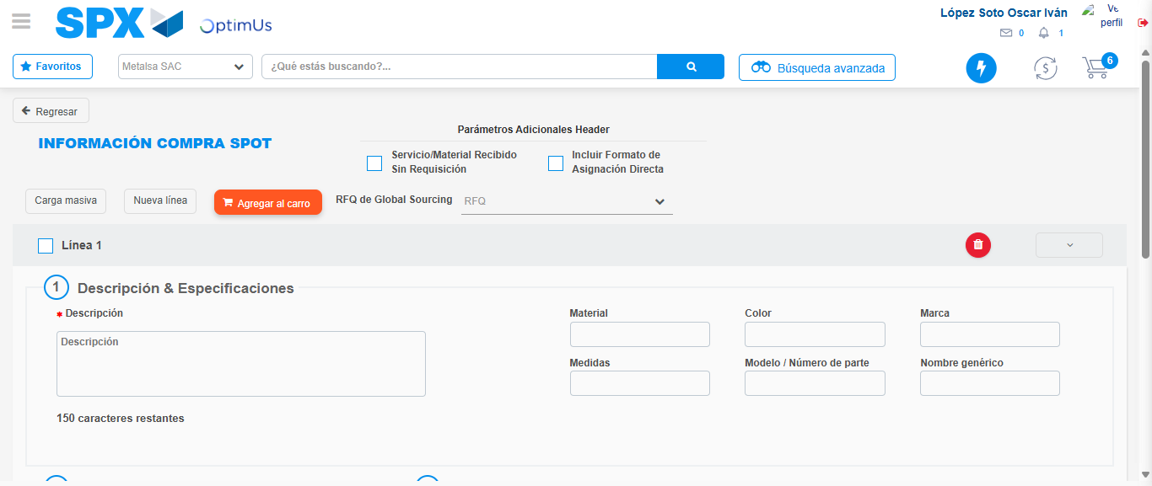Image file-name: QC_Testing-tc005_SPX_Dev5_Crear_Requisicion_Spot_Con_FAD_Tipo_Cobro_Project-1784573025326

Step 3 - Add FAD to Requisition: FAD Successfully Added
Image file-name: QC_Testing-tc005_SPX_Dev5_Crear_Requisicion_Spot_Con_FAD_Tipo_Cobro_Project-1784573025597

Image file-name: QC_Testing-tc005_SPX_Dev5_Crear_Requisicion_Spot_Con_FAD_Tipo_Cobro_Project-1784573025809

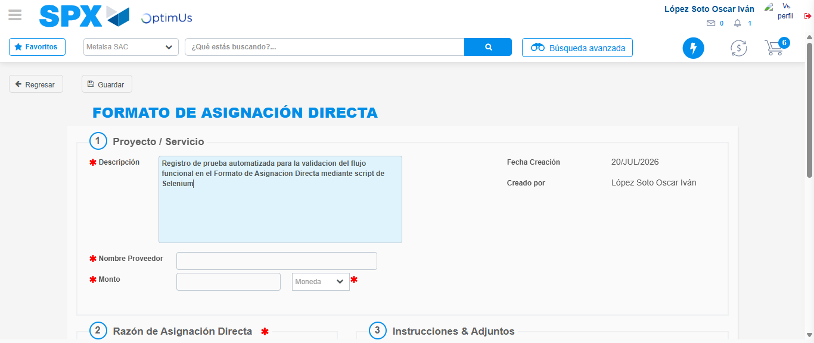Image file-name: QC_Testing-tc005_SPX_Dev5_Crear_Requisicion_Spot_Con_FAD_Tipo_Cobro_Project-1784573028851

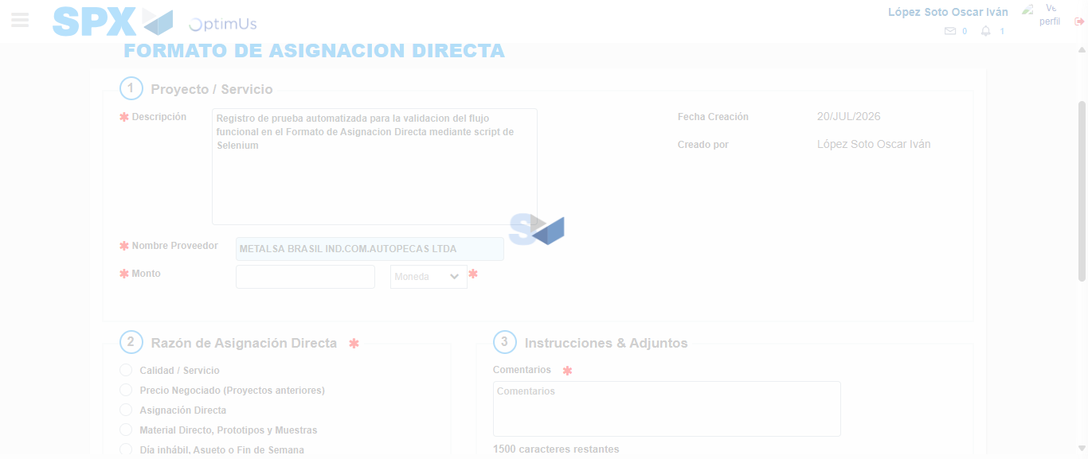Image file-name: QC_Testing-tc005_SPX_Dev5_Crear_Requisicion_Spot_Con_FAD_Tipo_Cobro_Project-1784573035757

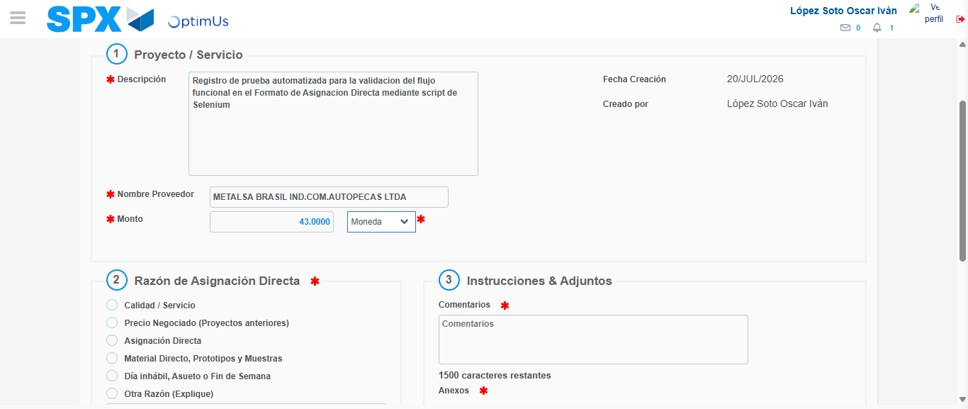Image file-name: QC_Testing-tc005_SPX_Dev5_Crear_Requisicion_Spot_Con_FAD_Tipo_Cobro_Project-1784573036302

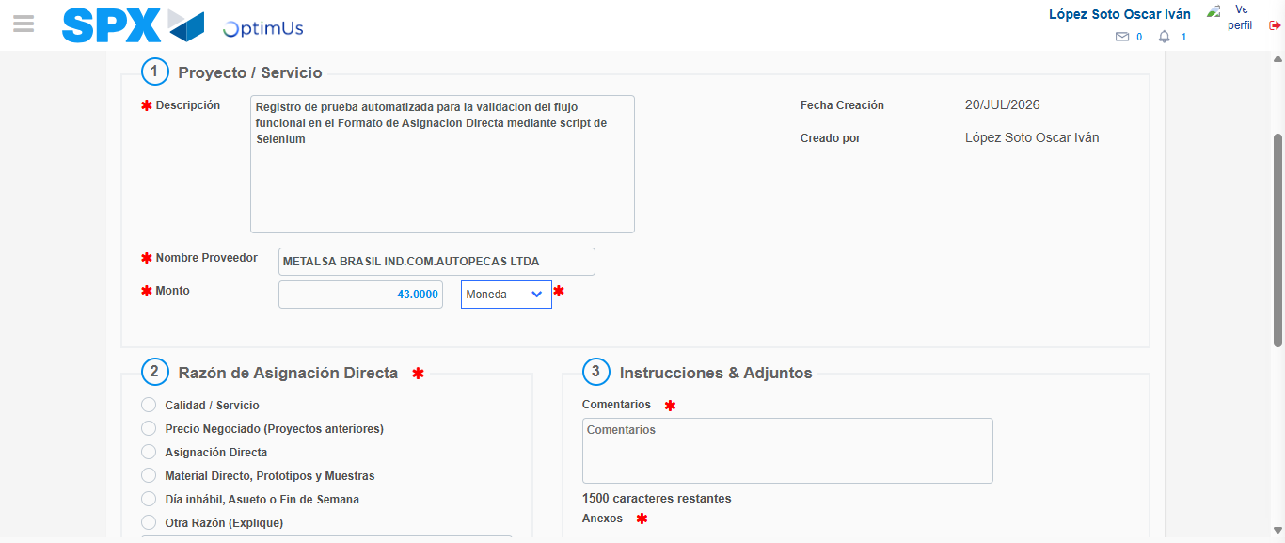Image file-name: QC_Testing-tc005_SPX_Dev5_Crear_Requisicion_Spot_Con_FAD_Tipo_Cobro_Project-1784573036535

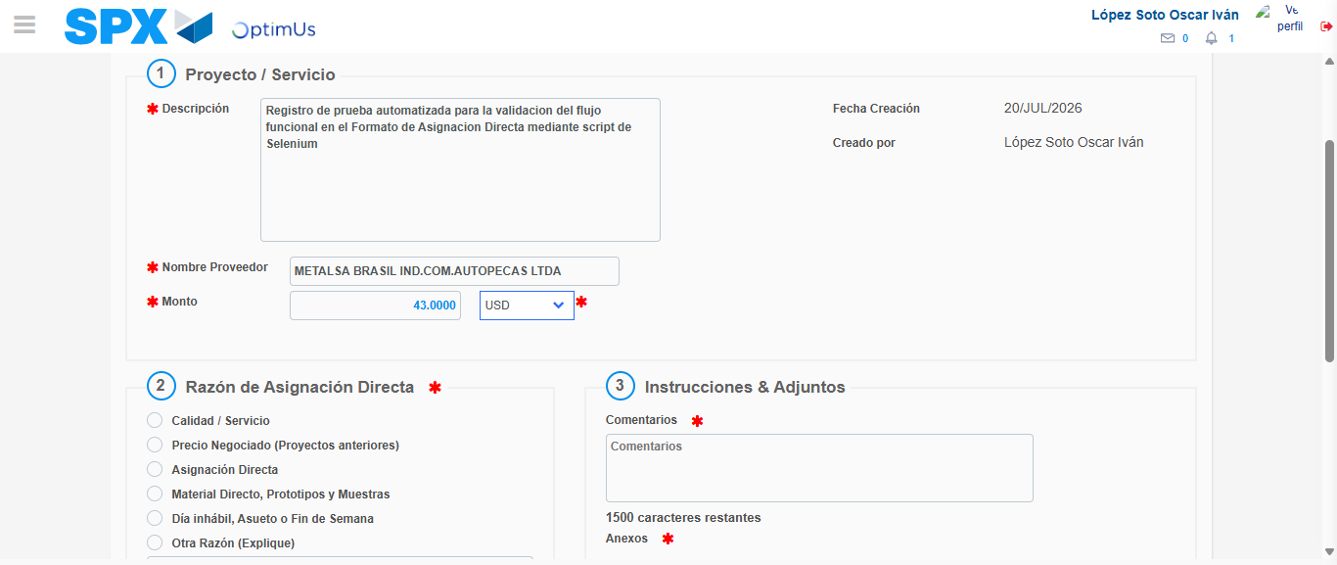Image file-name: QC_Testing-tc005_SPX_Dev5_Crear_Requisicion_Spot_Con_FAD_Tipo_Cobro_Project-1784573036985

Image file-name: QC_Testing-tc005_SPX_Dev5_Crear_Requisicion_Spot_Con_FAD_Tipo_Cobro_Project-1784573037184

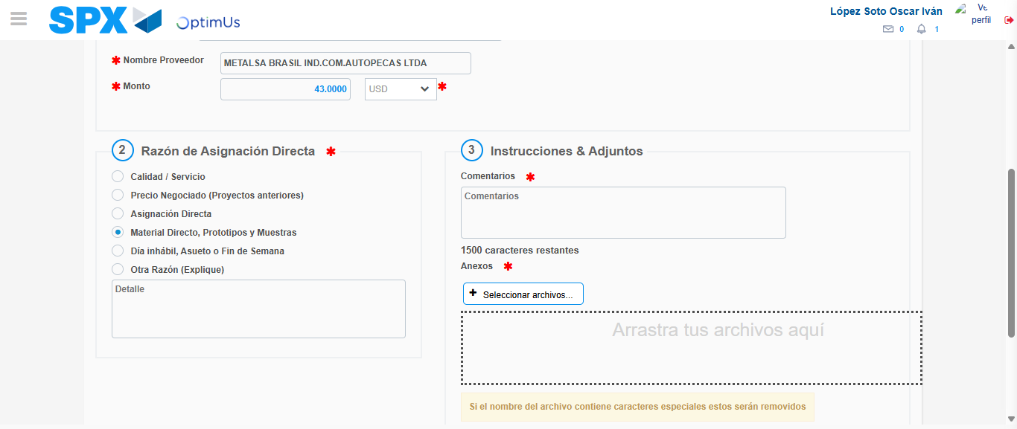Image file-name: QC_Testing-tc005_SPX_Dev5_Crear_Requisicion_Spot_Con_FAD_Tipo_Cobro_Project-1784573038155

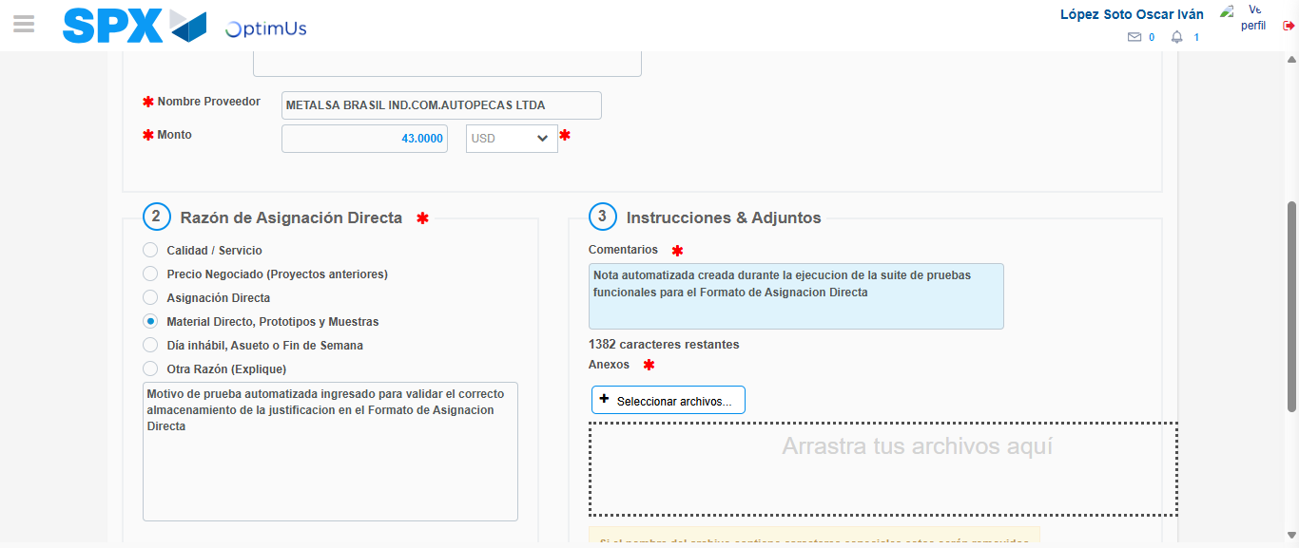Image file-name: QC_Testing-tc005_SPX_Dev5_Crear_Requisicion_Spot_Con_FAD_Tipo_Cobro_Project-1784573049645

Image file-name: QC_Testing-tc005_SPX_Dev5_Crear_Requisicion_Spot_Con_FAD_Tipo_Cobro_Project-1784573050460

Step 4 - Data Capture Spot Buy Requisition: Data captured correctly
Image file-name: QC_Testing-tc005_SPX_Dev5_Crear_Requisicion_Spot_Con_FAD_Tipo_Cobro_Project-1784573025597

Image file-name: QC_Testing-tc005_SPX_Dev5_Crear_Requisicion_Spot_Con_FAD_Tipo_Cobro_Project-1784573025809

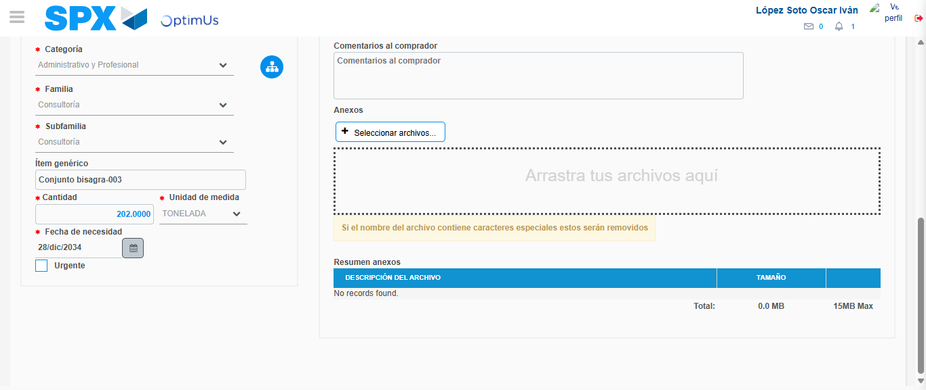Image file-name: QC_Testing-tc005_SPX_Dev5_Crear_Requisicion_Spot_Con_FAD_Tipo_Cobro_Project-1784573064333

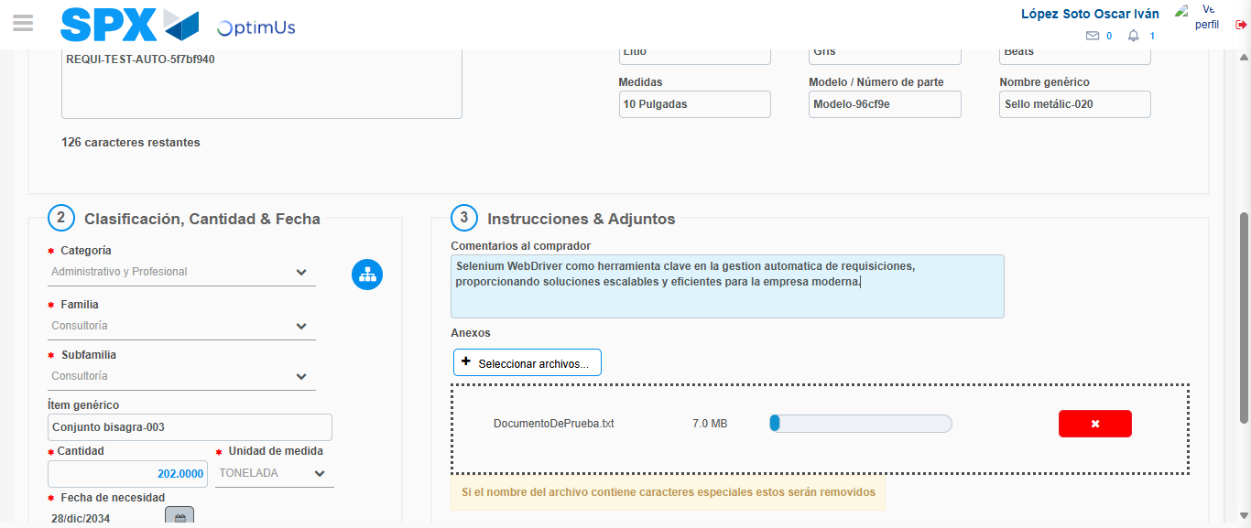Image file-name: QC_Testing-tc005_SPX_Dev5_Crear_Requisicion_Spot_Con_FAD_Tipo_Cobro_Project-1784573065284

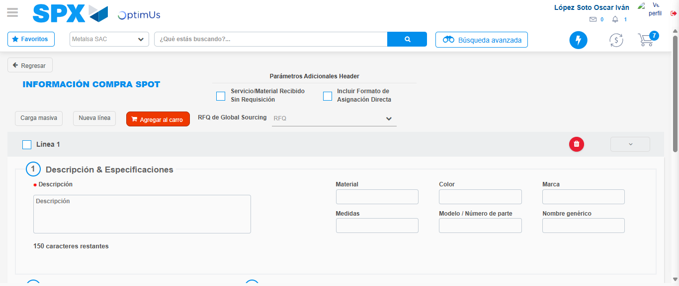Image file-name: QC_Testing-tc005_SPX_Dev5_Crear_Requisicion_Spot_Con_FAD_Tipo_Cobro_Project-1784573075019

Step 8 - Return to Main Page SPX : Return to Main Page SPX
Image file-name: QC_Testing-tc005_SPX_Dev5_Crear_Requisicion_Spot_Con_FAD_Tipo_Cobro_Project-1784573006677

Image file-name: QC_Testing-tc005_SPX_Dev5_Crear_Requisicion_Spot_Con_FAD_Tipo_Cobro_Project-1784573009455

Image file-name: QC_Testing-tc005_SPX_Dev5_Crear_Requisicion_Spot_Con_FAD_Tipo_Cobro_Project-1784573025326

Image file-name: QC_Testing-tc005_SPX_Dev5_Crear_Requisicion_Spot_Con_FAD_Tipo_Cobro_Project-1784573077332

Image file-name: QC_Testing-tc005_SPX_Dev5_Crear_Requisicion_Spot_Con_FAD_Tipo_Cobro_Project-1784573077520

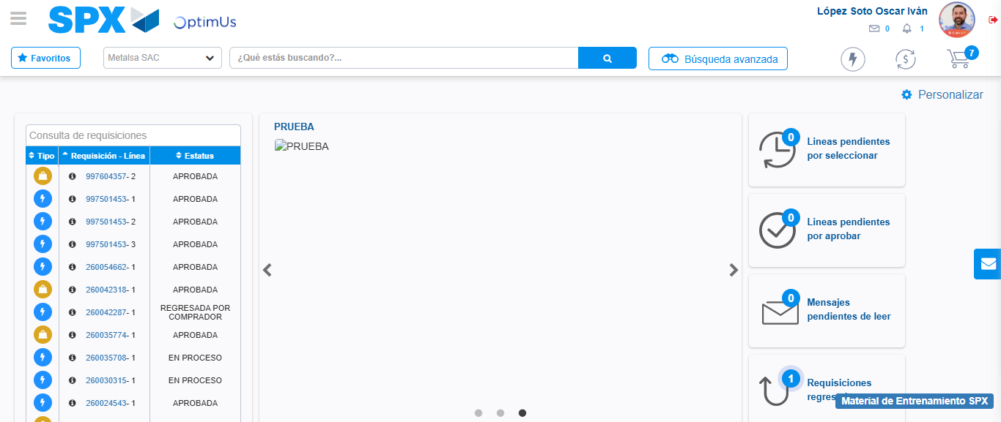Image file-name: QC_Testing-tc005_SPX_Dev5_Crear_Requisicion_Spot_Con_FAD_Tipo_Cobro_Project-1784573098954

Step 9 - Log Out : Log Out SPX
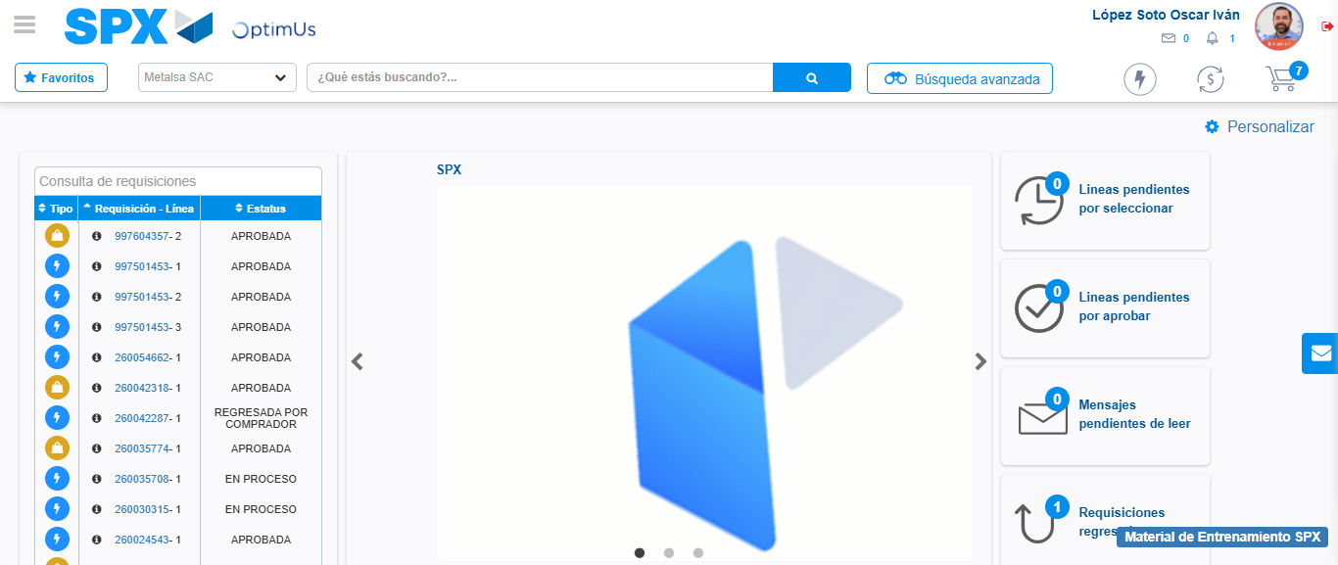Image file-name: QC_Testing-tc005_SPX_Dev5_Crear_Requisicion_Spot_Con_FAD_Tipo_Cobro_Project-1784573099355

